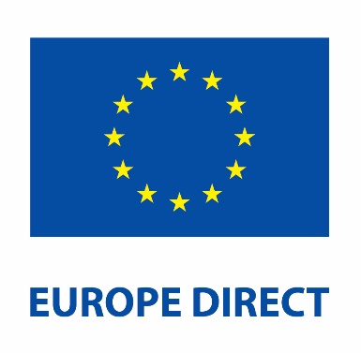
Europe Direct Soapbox Competition

Application Form
There’s no such thing as a vote that doesn’t matter – Barack Obama
In today’s turbulent times, it is more important than ever to build a better future by voting in the EU Parliament Elections.

How to apply
Submit the form by email to your local Europe Direct Sligo to bcawley@sligococo.ie

Application Form
Europe Direct: _________________________________

Category: ☐ 16 & under ☐ 17 & over

Name: ______________________________________________________________

Age (if entering 16 & under category): ____________________________________

Address: ____________________________________________________________

Contact Telephone Number: ____________________________________________

Email: _______________________________________________________________

Applicant, please read and sign below:
I have read the rules regarding the soapbox events and agree to abide by them.

Signature of applicant: ________________________________________________
Date: ______________________________________________________________

